**Final Report**

**for**

**BiFrost Games**

**By**

**Curtis Naples**

**Devan Weber**

**Evan Plant**

**Pat Horler**

Contents

1. Project Specifications 3

1.1 Function Requirements 3

1.2 Non-Function Requirements 3

1.3 Group Roles 3

2. Usability Guide 3

3. Problems and Challenges 3

4. Skill Learned 3

5. Proposed Changes 3

6. Code Snippets 3

**Table of Figures**

Figure 1 - UML Use Case Diagram 3

Figure 2 - Data Model Diagram 4

Figure 3 - Cart 5

Figure 4 - Login Screen 5

## Project Overview

We are creating a website that will be able to have video games posted and sold. A shopping cart will be implemented so customers can add multiple games to the cart and buy them in one transaction. The games will be able to be sorted by console and genre simultaneously. Customers must make an account to save their order history and be able to place orders.

## Project Specifications

### 2.1 Function Requirements

1. The customer must be able to browse items and select category filters.
2. An item must be able to be added to, edited, or removed from the shopping cart.
3. The customer can purchase the contents of the cart using a secure payment system.
4. The customer can have an account on the system.
5. The customer can view their purchase history.
6. The client can add products to the system.

### 2.2 Non-Function Requirements

1. The system will be built using apache web server
2. The front end will be coded using HTML, CSS and Javascript
3. The middleware will be built with PHP
4. The database will be built using Oracle SQL
5. The system must provide a consistent look and feel across the user interface
6. The system will use free open source software
7. The system must be fully tested and running in 8 weeks

### 2.3 Group Roles

Curtis Naples Front-End Developer, Middle-ware Developer, Team Lead

Devan Weber Front-End Developer, Middle-ware Developer, Database/Back-end Developer

Evan Plant Database/Back-end Developer, Middle-ware Developer, Front-End Developer

Pat Horler Team Lead, Front-End Developer, Technical Writer

## Usability Guide

*< This should be in the form of a step-by-step guide that walks a user through the functionality of the website and include screenshots.>*

…

## Problems and Challenges

*< Problems and challenges you faced as a group during the project. This should include a description of each problem and how you overcame it>*

Problem - changing the quantity without reloading the page

Solution - learned how to use ajax to change quantity with a server sided script. Explained in code snippets

Problem – Git conflicts when pushing your work

Solutions – Ensuring that the most recent version of master was pulled and rebased in branch before work begins

Problem – Git problems with temp files made by Microsoft when file is open

Solutions – Close all windows before pushing to git

Problem: Adopting change requests into "completed" code.

Solution: Re-think the code logic to effectively accommodate new and existing functionality.

## Skill Learned

*<What your team learned (include both technical and soft skills)>*

* Learned how to use ajax with jQuery to run server sided scripts
* Learned how to use git properly and how to coordinate the team using it
* Planning and time management
* Re-using code to make tasks easier
* How to work on code together with another teammate.
* How to organize project tasks with MS Project.
* How to design code to be more modular (i.e. using header/footer.php files).
* How to integrate external code (i.e. Stripe).
* How to use php to create dynamic web pages.
* How to use php to interact with a database.

## Proposed Changes

*<What your team would do differently next time>*

* Plan out the design/pages needed more carefully.

## Code Snippets

*<A couple of blocks of your team’s code showing examples from the back-end, middle-ware and front-end. Explain what it does and why your team is proud of it!>*

Using ajax for quantity

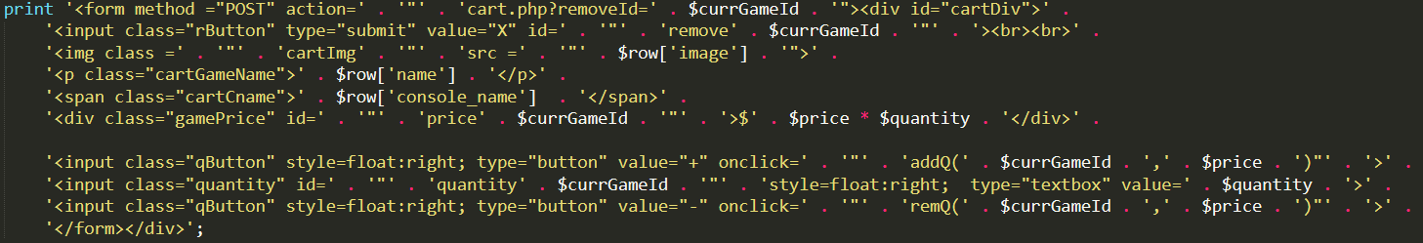

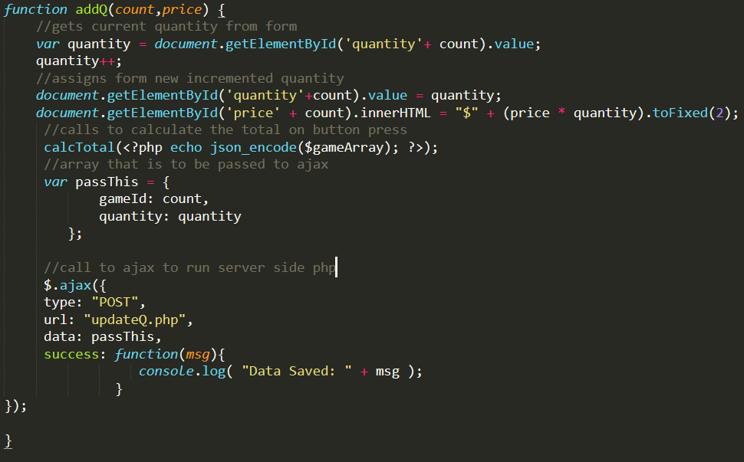

Login Redirect

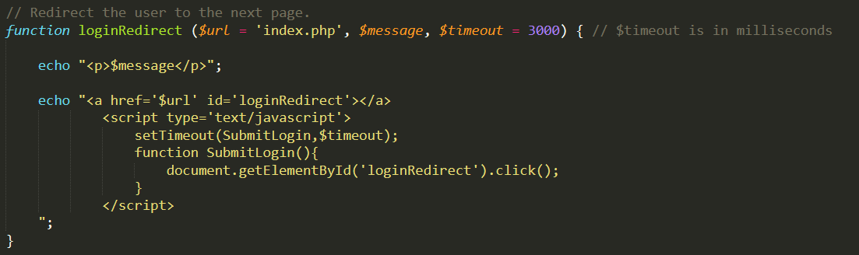

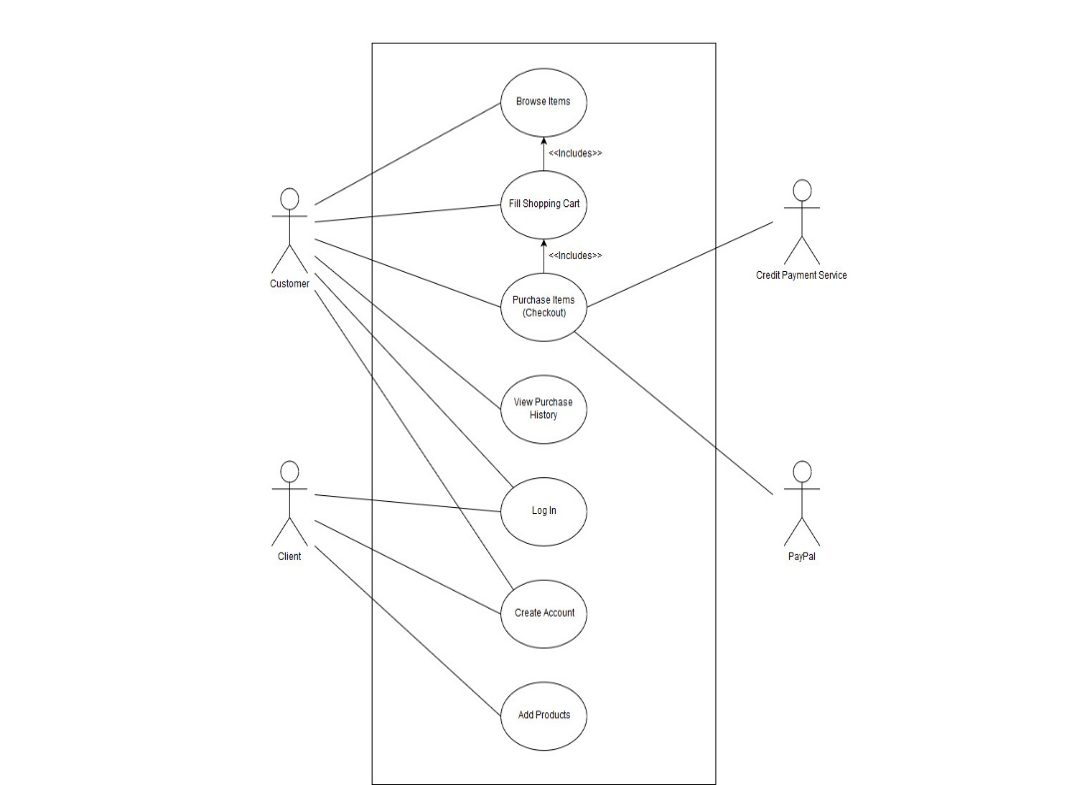

**Figure 1 - UML Use Case Diagram**

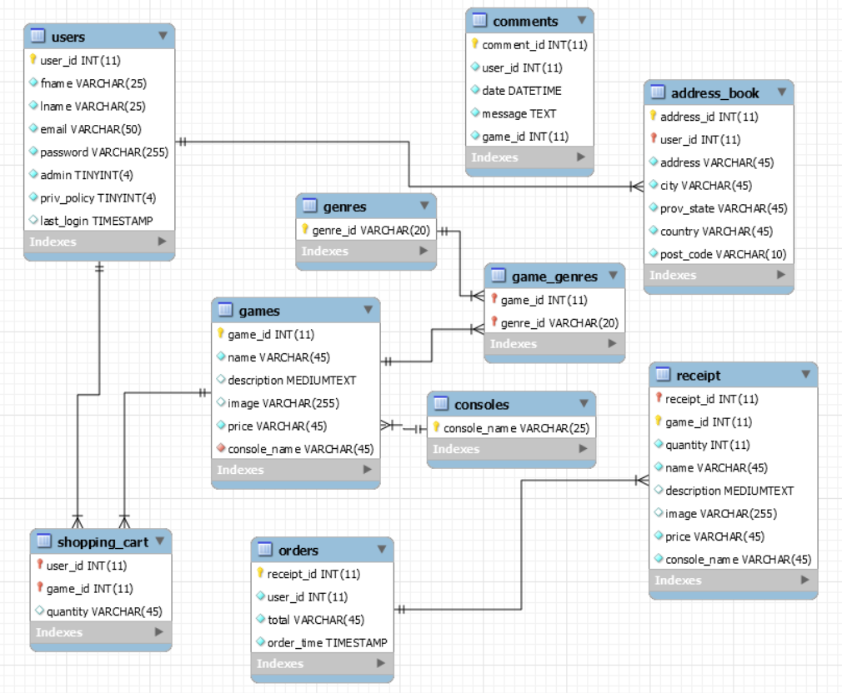

**Figure 2 – Data Model Diagram**

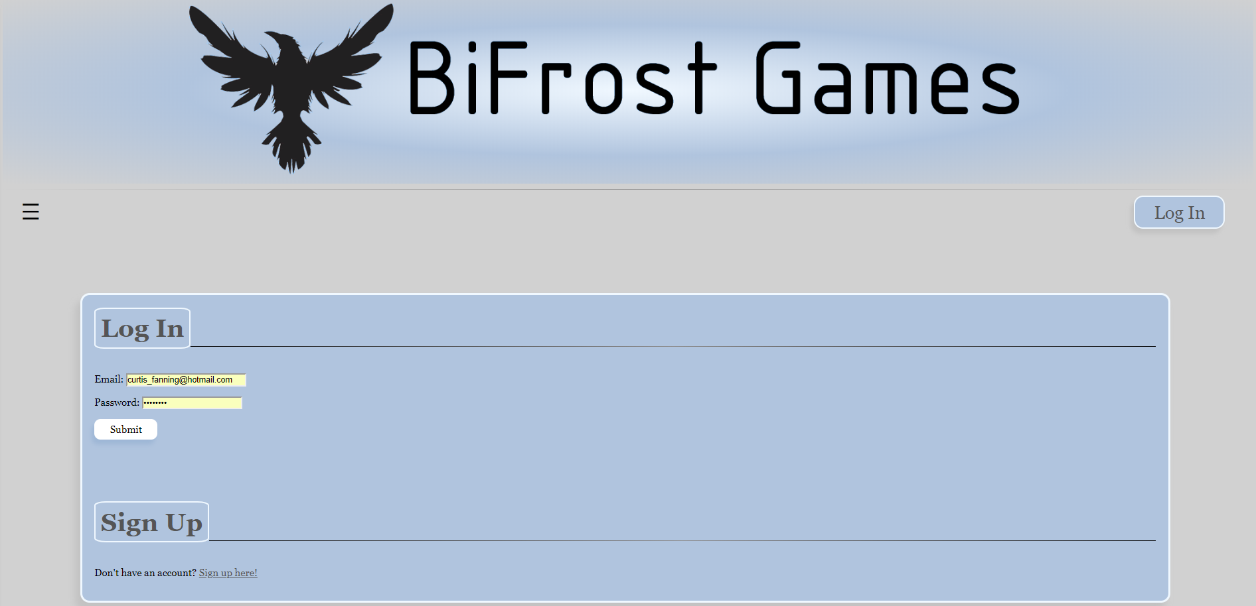

**Figure 3 – Login page**

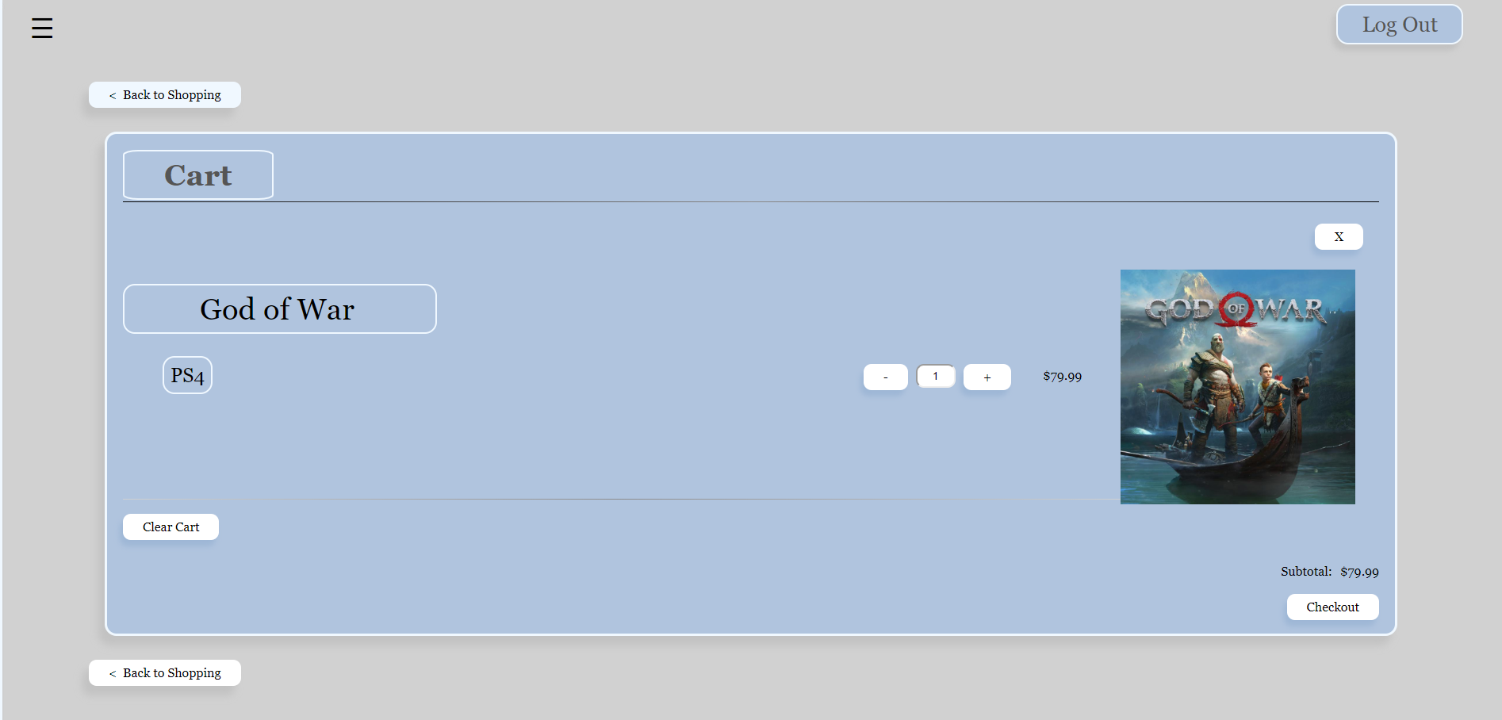

**Figure 4 – Cart page**